Dataset Shape: (500, 9)
Columns: Index(['CustomerID', 'Tenure', 'MonthlyCharges', 'TotalCharges', 'Contract',
'PaymentMethod', 'PaperlessBilling', 'SeniorCitizen', 'Churn'],
dtype='object')

===== DESCRIPTIVE STATISTICS =====
Mean: 4,237.88
Median: 4,182.50
Mode: 4,023.00
Std Dev: 2,260.62
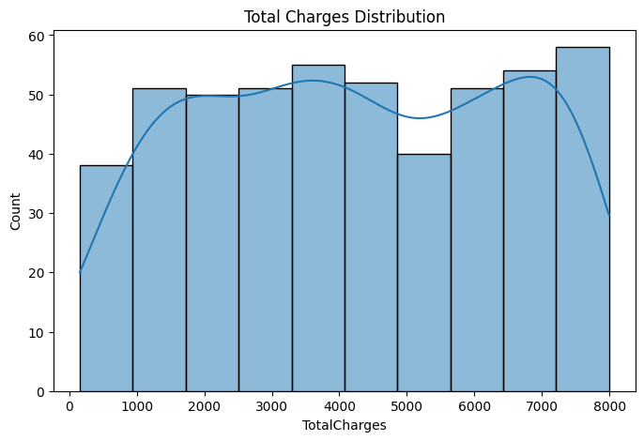
Shapiro Test p-value: 9.382971874467683e-12

Correlation Matrix:
Tenure MonthlyCharges TotalCharges SeniorCitizen \
Tenure 1.000000 -0.059655 -0.005677 -0.040001
MonthlyCharges -0.059655 1.000000 -0.042280 -0.105695
TotalCharges -0.005677 -0.042280 1.000000 0.016360
SeniorCitizen -0.040001 -0.105695 0.016360 1.000000
Churn -0.509208 0.107381 0.004250 -0.018114

Churn
Tenure -0.509208
MonthlyCharges 0.107381
TotalCharges 0.004250
SeniorCitizen -0.018114
Churn 1.000000
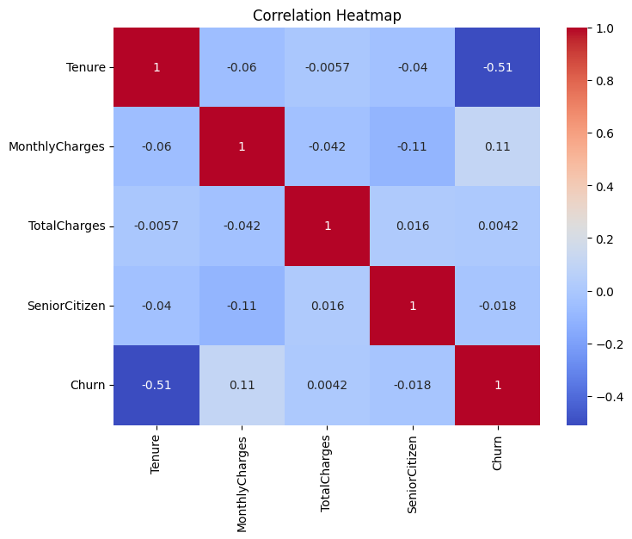

===== HYPOTHESIS TESTING =====
H1: MonthlyCharges vs TotalCharges
p-value: 0.3454473333894217

H2: Senior vs Non-Senior
p-value: 0.7151707484894925

H3: Contract Type ANOVA
p-value: 0.23318247397532763

95% Confidence Interval:
4,039.25 to 4,436.51

===== REGRESSION RESULTS =====
OLS Regression Results
==============================================================================
Dep. Variable: TotalCharges R-squared: 0.002
Model: OLS Adj. R-squared: -0.002
Method: Least Squares F-statistic: 0.4618
Date: Wed, 25 Feb 2026 Prob (F-statistic): 0.630
Time: 15:01:50 Log-Likelihood: -4570.2
No. Observations: 500 AIC: 9146.
Df Residuals: 497 BIC: 9159.
Df Model: 2
Covariance Type: nonrobust
==================================================================================
coef std err t P>|t| [0.025 0.975]
----------------------------------------------------------------------------------
const 4482.8713 311.064 14.411 0.000 3871.708 5094.035
MonthlyCharges -1.8666 1.959 -0.953 0.341 -5.716 1.983
Tenure -0.9000 4.911 -0.183 0.855 -10.548 8.748
==============================================================================
Omnibus: 380.832 Durbin-Watson: 1.952
Prob(Omnibus): 0.000 Jarque-Bera (JB): 31.341
Skew: -0.031 Prob(JB): 1.56e-07
Kurtosis: 1.775 Cond. No. 397.
==============================================================================

Notes:
[1] Standard Errors assume that the covariance matrix of the errors is correctly specified.

R-Squared: 0.0018550319992883813

============================================================
STATISTICAL ANALYSIS REPORT
============================================================
Average Revenue: $4,238 ± $199 (95% CI)
Correlation (MonthlyCharges-TotalCharges): -0.04
p-value: 0.3454
============================================================

